Predicting Falcon 9 Landing Success
A Machine Learning Approach Using Launch Data and Exploratory Analysis
Grayson Klein
2026
Executive Summary
This project aims to predict the success of Falcon 9 first-stage landings which play a key role in the cost estimation of SpaceX launches based on whether the rocket can be reused in future missions. This analysis uses data from the Space X API along with Wikipedia sources on Falcon 9 launch information. Both static and interactive visuals were used to identify patterns between various factors including launch site, payload mass, orbit type, and flight number. Interactive dashboards built with Folium and PlotlyDash provide insight into geographic elements like landing locations.
Multiple machine learning models were trained and evaluated, including logistic regression, support vector machine (SVM), decision tree, and K-nearest neighbor (KNN). Models were assessed using metrics such as test accuracy, precision, recall, and F1-score. All models achieved similar performance, so logistic regression was selected as the final model due to its simplicity and interpretability.
The model achieved an accuracy of approximately 0.83, indicating strong performance; however, the small dataset size limits the reliability of these results. With more data, model performance may differ and provide a more accurate and generalizable estimate.

Table of Contents
Introduction ……………………………………………………… 4
Methodology………………………………………………..…… 4
Results & Discussion………………………………………..… 5
Conclusion…………………………………………………..…… 7
References……………………………………………………..… 8

Introduction
SpaceX has managed to significantly reduce the cost of space launches by reusing their rockets, specifically the Falcon 9, in subsequent missions. A key factor in this cost reduction is whether these rockets are viable for reuse based on their landing outcomes. This project analyzes historical Falcon 9 launch data to determine whether landing outcomes can be accurately predicted using machine learning models. Data was collected from the SpaceX API and combined with information from Wikipedia. Through data analysis and both static and interactive visualizations, key factors influencing landing success were identified, and a predictive model was built to estimate launch outcomes and support cost analysis and decision-making.

Methodology
To carry out this analysis, data was collected from the SpaceX API and combined with information from Wikipedia to create a comprehensive dataset of Falcon 9 launches. The data was then cleaned and prepared by handling missing values, with null payload values filled using the mean, and by creating a binary landing outcome variable with 1 indicative of successful landings and 0 failed landing. Exploratory data analysis was performed using both SQL queries and visualizations to identify patterns and relationships between key variables such as payload mass, orbit type, launch site, and flight number. Interactive visualizations were developed using Folium and Plotly Dash to further explore geographic and operational trends. Finally, four machine learning classification models, including logistic regression, support vector machine (SVM), decision tree, and K-nearest neighbor (KNN), were trained and evaluated using techniques such as train test splitting, feature scaling, and GridSearchCV with cross validation. Based on model performance, the most appropriate model was selected to predict landing success.

Results & Discussion
Several trends were revealed through the analysis. Overall, success rates generally increased over time. Although there was a noticeable dip in 2018, the general trend from 2010 to 2020 shows a steady improvement in landing success rates, likely reflecting advancements in technology and operational experience (see Figure 1). In terms of orbit types, several outperformed others, including ES-L1, GEO, HEO, and SSO, which all achieved similarly high success rates, whereas orbit type SO had no successful landings (see Figure 2).
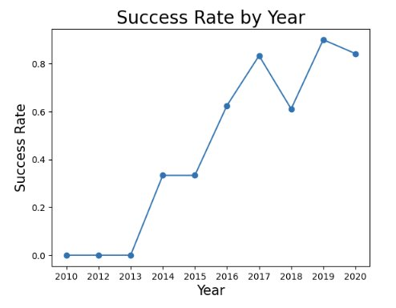
Figure 1: Launch Success Rate by Year
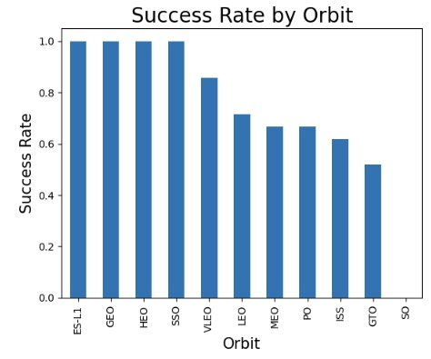
Figure 2: Launch Success Rate vs. Orbit
Analysis of payload mass in relation to launch site and landing outcomes showed that heavier payloads generally performed well, with most launches around and above 10,000 kg being successful (see Figure 3). However, there were also many successful launches with lower payload masses. While failures were more common among lighter payloads, it is also important to note that a greater number of launches occurred in the lower payload range, which may contribute to the higher number of observed failures.

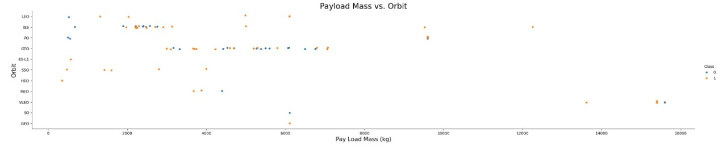
Figure 3: Payload Mass vs. Orbit

Overall, these findings highlight that landing success is influenced by multiple factors and that these patterns can be effectively captured using predictive modeling. The machine learning models were able to leverage these relationships to estimate landing outcomes with an accuracy of approximately 0.83, indicating reasonably strong predictive capability. No single model outperformed the others, as all four models misclassified only three landings (see Figure 4). Therefore, logistic regression was selected as the final model due to its simplicity and interpretability.

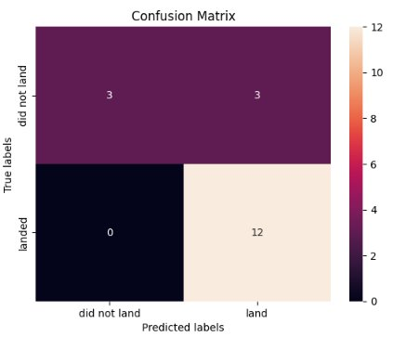
Figure 4: Logistic Regression Confusion Matrix
However, while the accuracy was relatively high, this does not necessarily indicate a reliable model given the very small sample size. With such a limited dataset, the model may be overfitting to the data and capturing patterns that do not generalize well to new observations. If a larger dataset were used for training and testing, the results would likely differ and provide a more accurate representation of model performance. Increasing the amount of data would be a necessary improvement to enhance the reliability and generalizability of the model.

Conclusion
Overall, this project demonstrates that Falcon 9 landing outcomes can be analyzed and reasonably predicted using data-driven approaches. Through a combination of data collection, visualization, and machine learning, key patterns and relationships were identified that help explain variations in landing success. While the models showed strong performance, the results should be interpreted with caution due to the limited dataset. To better support cost estimation and operational decision-making for similar launches, a larger dataset should be used to improve model performance. This would be a worthwhile investment as it would allow for more reliable and useful insights which can be utilized to estimate and potentially reduce the costs of future missions.

References
- SpaceX API. Retrieved from https://api.spacexdata.com
- Wikipedia. List of Falcon 9 and Falcon Heavy Launches. Retrieved from
https://en.wikipedia.org/wiki/List_of_Falcon_9_and_Falcon_Heavy_launches
- GitHub Repository. SpaceX Capstone Project. Retrieved from
https://github.com/Kleiner7/SpaceXCapstone/tree/main

